**Assignment No:-19**

Name:-Suryawanshi Sangramsingh Sambhaji

Batch: - Delta - DCA (Java) 2024 Date:-29/5/2024

**Q4.You are given two arrays, A and B, of equal size N. The task is to find the minimum value of A[0] * B[0] + A[1] * B[1] + .... + A[N-1] * B[N-1], where shuffling of elements of arrays A and B is allowed.**

**Example 1:**

**Input:N = 3**

**A[] = {3, 1, 1}**

**B[] = {6, 5, 4}**

**Output: 23.**

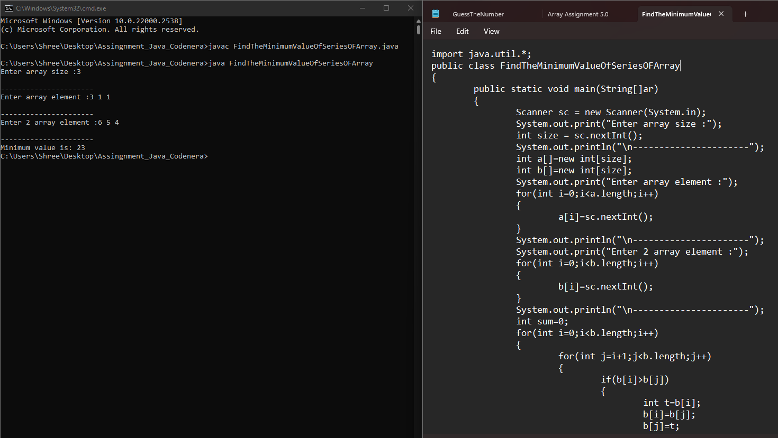

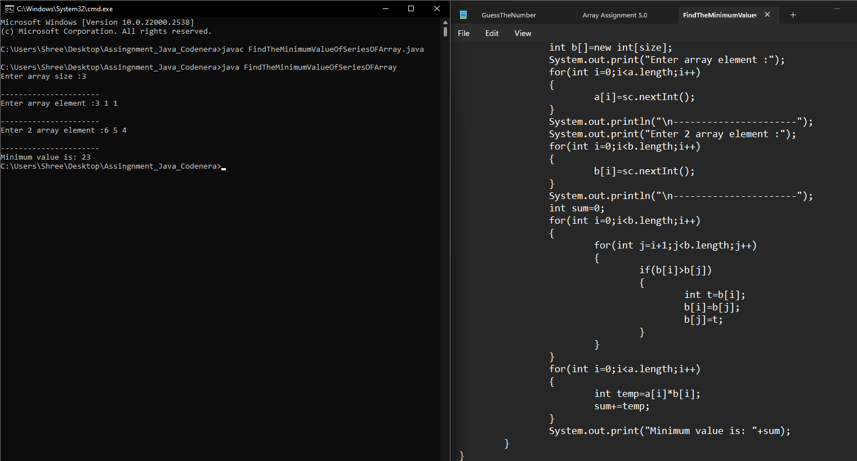

**Q5.Given two sorted arrays arr1 and arr2 of size N and M respectively and an element K. The task is to find the element that would be at the k’th position of the final sorted array.**

**Example 1:**

**Input: arr1[] = {2, 3, 6, 7, 9}**

**arr2[] = {1, 4, 8, 10}**

**k = 5**

**Output:6** 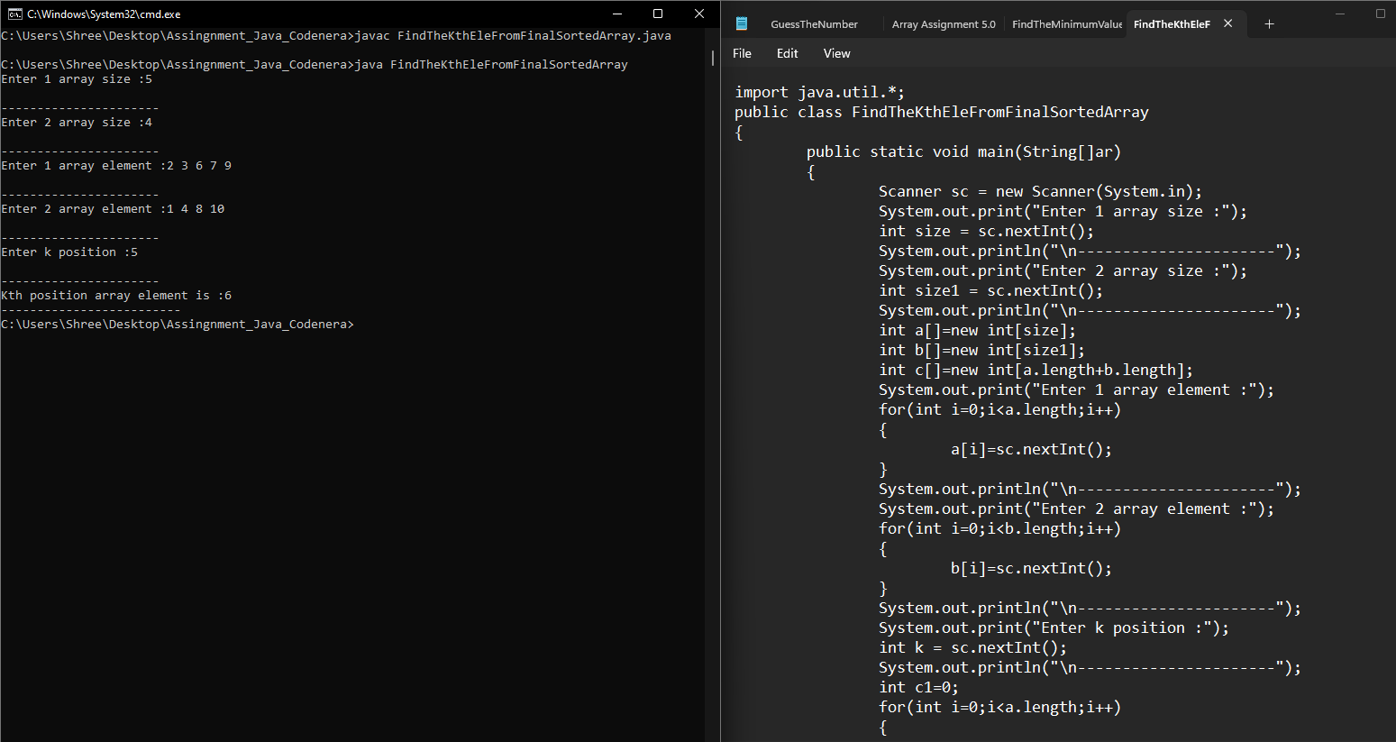 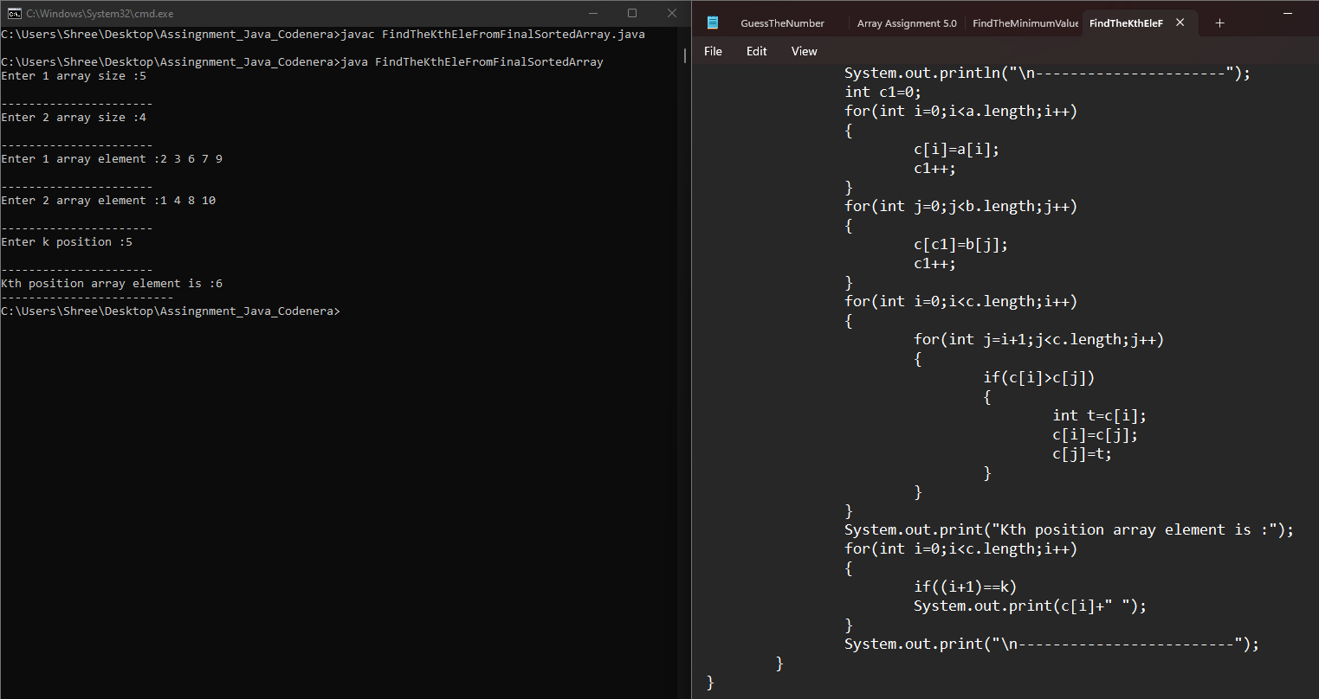

**Q6.Given an array of size N filled with numbers from 1 to N-1 in random order. The array has only one repetitive element. The task is to find the repetitive element.**

**Examples:**

**Input: a[] = {1, 3, 2, 3, 4}**

**Output: 3** 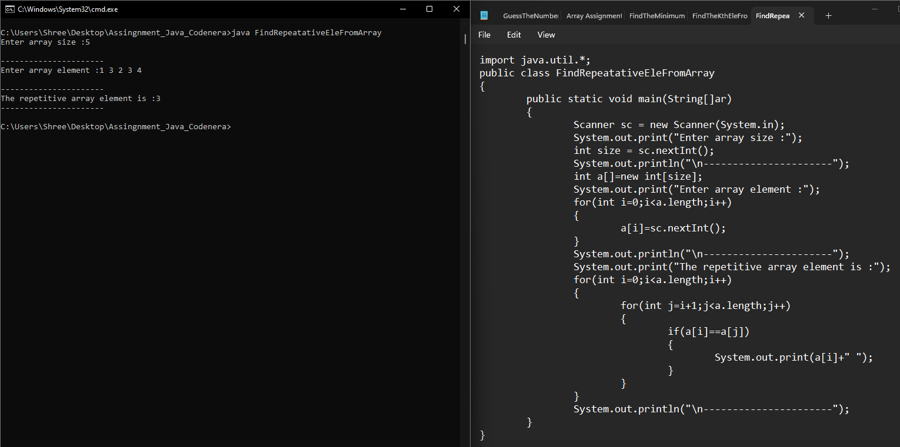

**Q7.Given two unsorted arrays that represent two sets (elements in every array are distinct), find the union and intersection of two arrays.**

**Example: arr1[] = {7, 1, 5, 2, 3, 6} arr2[] = {3, 8, 6, 20, 7}**

**Then your program should print Union as {1, 2, 3, 5, 6, 7, 8, 20} and Intersection as {3, 6, 7}. Note that the elements of union and intersection can be printed in any order.**

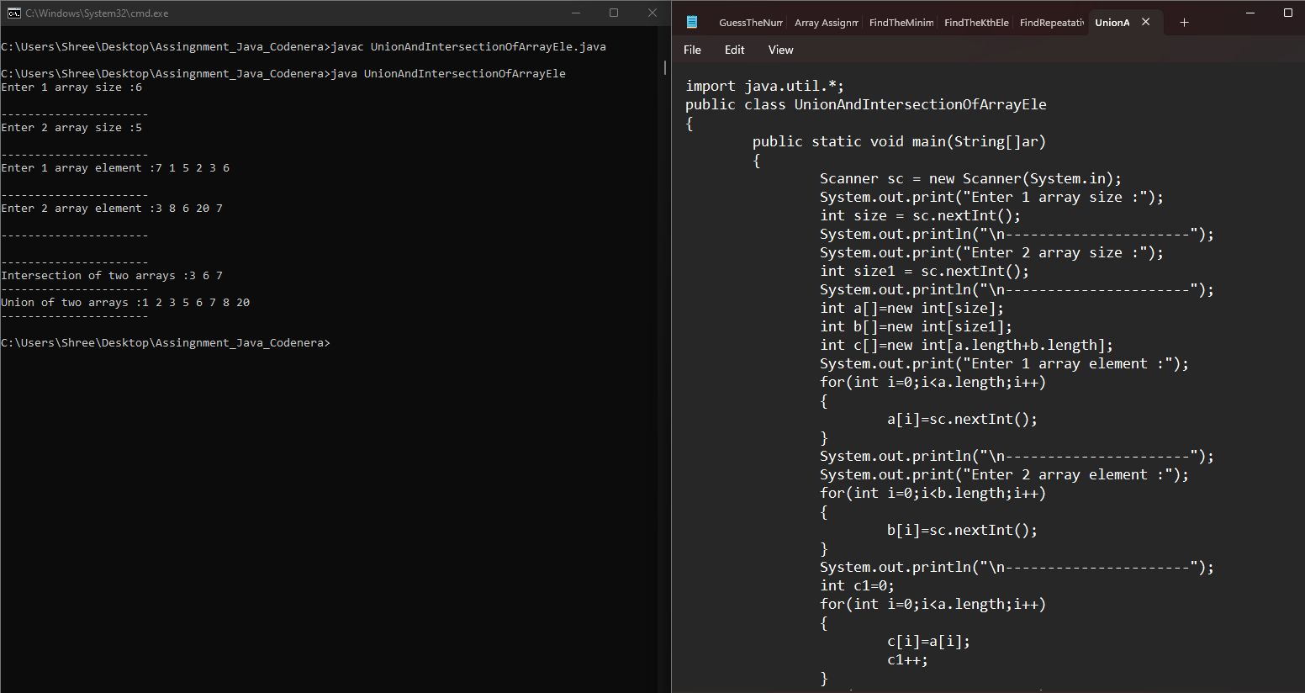 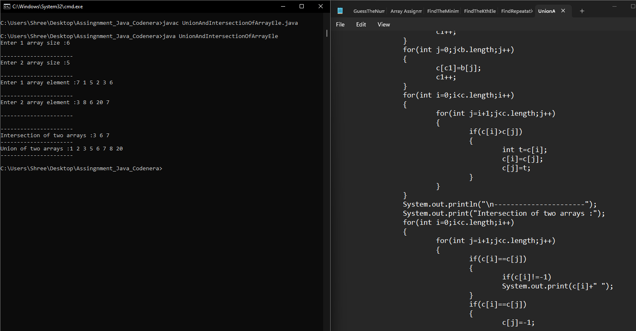

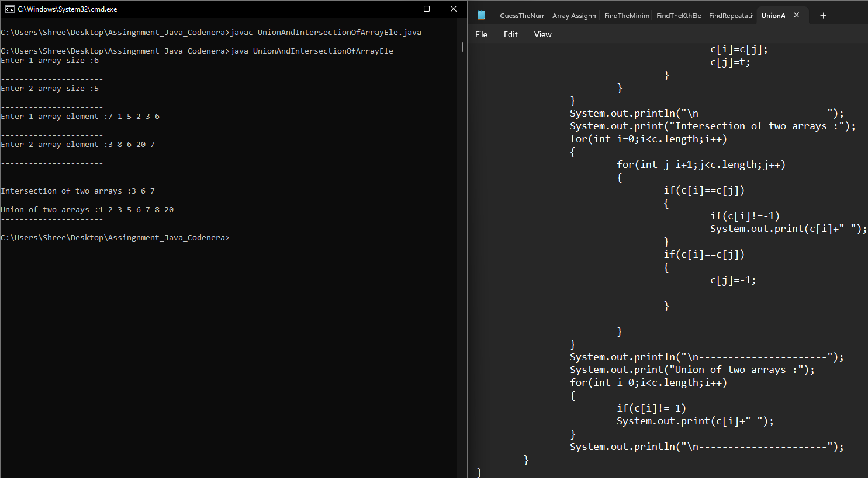

**Q8.Given three arrays sorted in non-decreasing order, print all common elements in these arrays.**

**Examples:**

**Input:**

**ar1[] = {1, 5, 10, 20, 40, 80}**

**ar2[] = {6, 7, 20, 80, 100}**

**ar3[] = {3, 4, 15, 20, 30, 70, 80, 120}**

**Output: 20, 80**

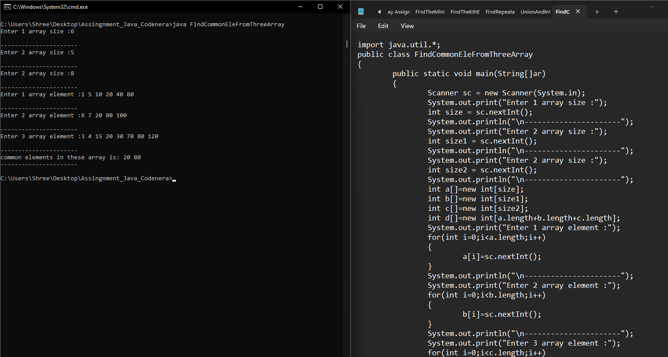

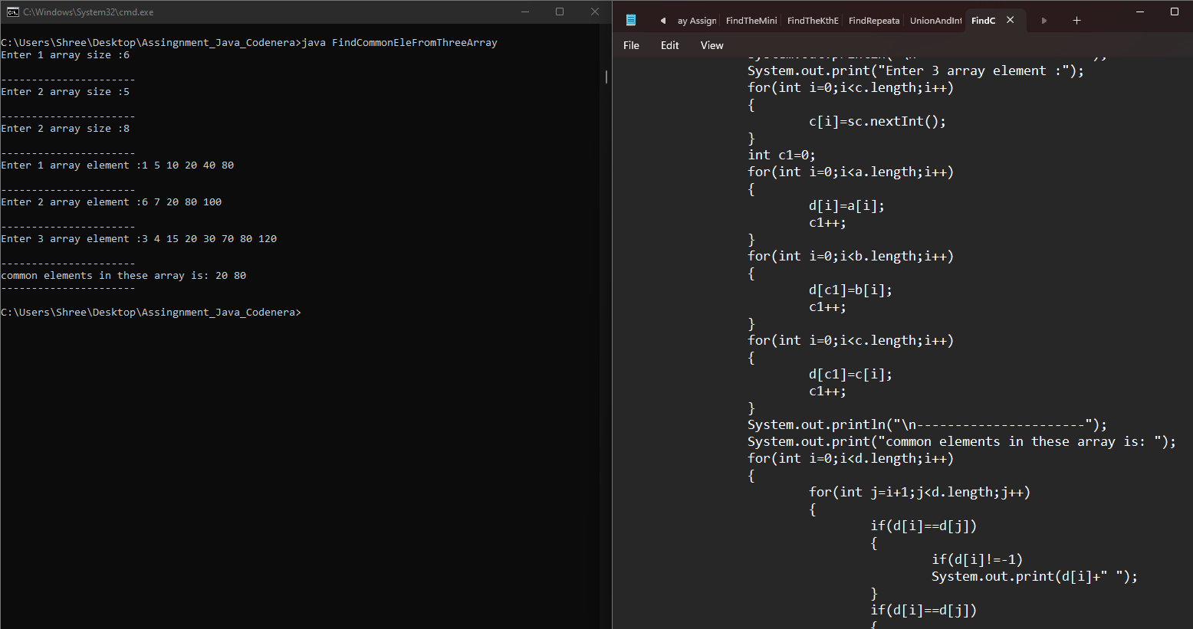 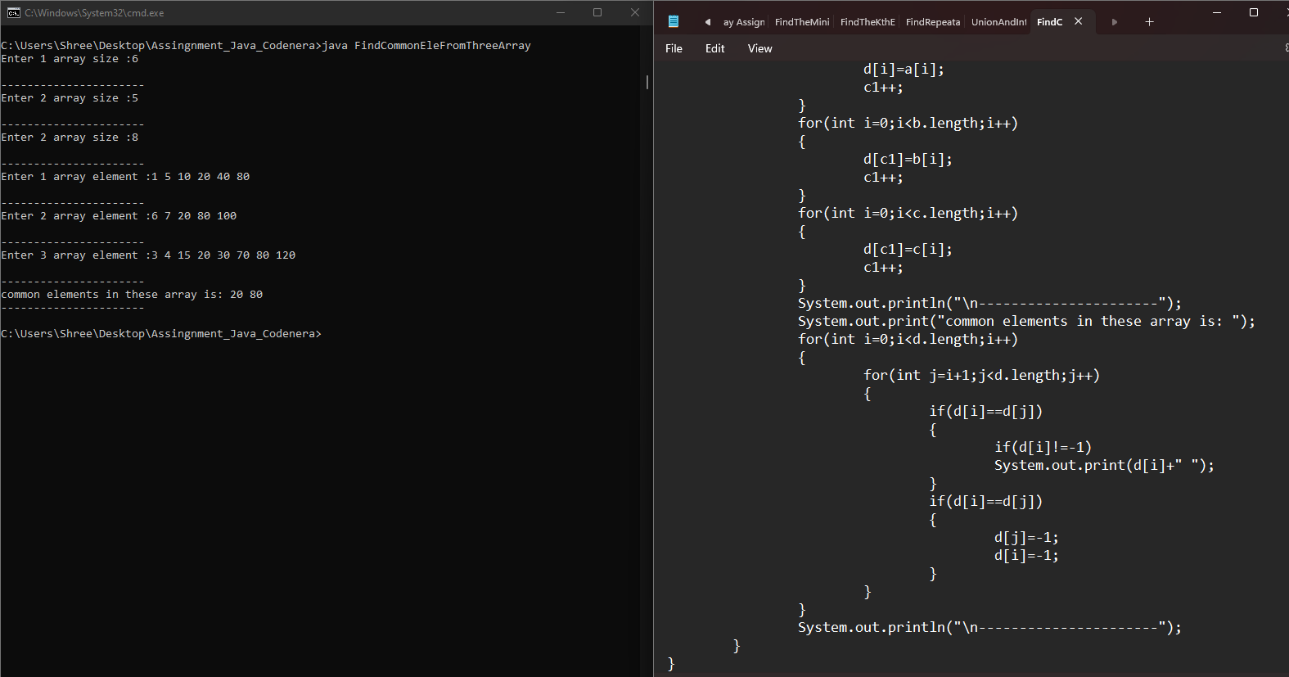

**Q9.Given an array of integers. All numbers occur twice except one number which occurs once.**

**Example :**

**Input: arr[] = {2, 3, 5, 4, 5, 3, 4}**

**Output: 2** 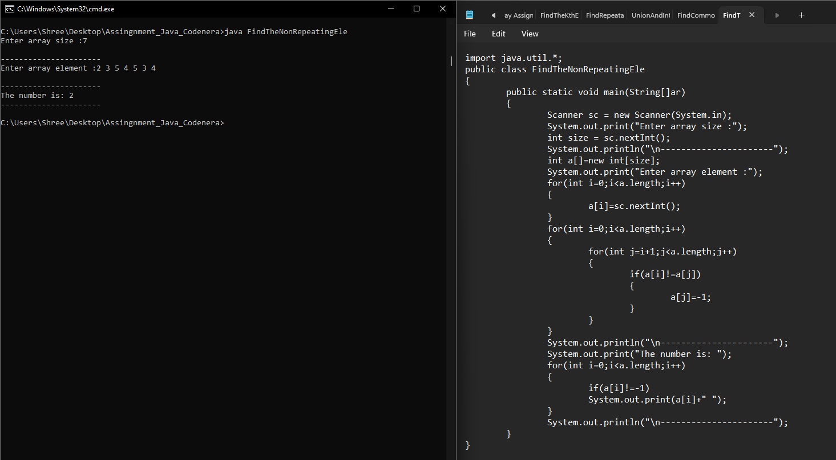

**Q11.Given a sorted array of n distinct integers where each integer is in the range from 0 to m-1 and m > n. Find the smallest number that is missing from the array.**

**Examples:**

**Input: {0, 1, 2, 6, 9}, n = 5, m = 10**

**Output: 3** 